Prediction of Inflow Volume in Wastewater Treatment Plant Incorporating Weather Condition Parameters Using Artificial Neural Network

A.C. Ilao*¹⁾, J.I. Colades¹⁾, M.R. Tabucal¹⁾, A.J. Manrique¹⁾
¹⁾Environmental Engineering Program, University of the Philippines Diliman, Quezon City, Philippines 1101
* acilao@up.edu.ph
Keywords: Artificial neural network (ANN); Inflow volume; Prediction; Weather condition parameter
Introduction
Water inflow of separate sewerage systems has relatively more stable pattern because it depends mostly on human behavior and water consumption. Combined sewer systems, on the other hand, do not only depend on this diurnal pattern but also on meteorological events (Breinholt et al., 2011; Wei, 2013).
Hydrological and hydraulic simulation models are used to predict hydraulic load. These models are tedious to calibrate because understanding the drainage area under study incorporating is needed. Hence, they are not effective and efficient in real-time control. The artificial neural network (ANN) is another model used for prediction that can recognize existing relationships between measurable input and output data of the system (Capodaglio, 1994). A study conducted by El-Din and Smith, an ANN model was used to make a short-term prediction of wastewater inflow rate that enters the largest plant in the Edmonton area, Alberta, Canada using rainfall data as input. The model can be used in real-time control system to minimize the total pollution load from the treatment plant (El-Din & Smith, 2002). Another study conducted by Wei and Kusiak used ANN to predict influent flow at a local wastewater treatment plant in Canada, including rainfall and radar reflectivity data as inputs. The proposed model can predict influent for time horizon up to 300 min (Wei & Kusiak, 2015).
This study aimed to predict wastewater inflow volume of a wastewater treatment facility in Quezon City, Philippines integrating weather condition parameters using ANN and to evaluate the accuracy in inflow volume prediction using existing data obtained from the plant.
Material and Methods
The weather condition parameters – maximum temperature, dew point, maximum humidity, mean humidity, mean temperature, and rainfall – obtained from the Philippine Atmosphere Geophysical and Astronomical Services Administration office were used as the input data of neural network. Rainfall data recorded at the Science Garden, Bureau of Internal Revenue Road, Quezon City, Philippines were used. On the other hand, the daily total wastewater inflow volume entering the Maynilad sewage treatment plants in Quezon City during March 2016-March2017 were used as the output data.
Correlation analysis was used to determine the combinations of weather condition parameters to be inputted in ANN.
Fig. 1 shows the typical architecture of the ANN used in this study. The network was trained for the period from March 2016 to December 2016. The applicability of the ANN was tested for the data in the period from January 2017 to March 2017. The coefficient of determination (R²), root mean square error (RMSE), and Nash-Sutcliffe model efficiency (NSE) were used to evaluate the model’s accuracy.
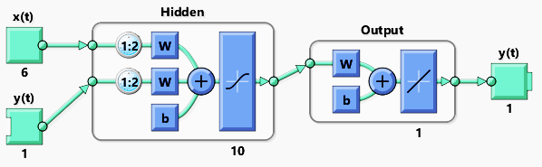
Figure 1. ANN architecture used in the study.
Results and Conclusions
Table 1 shows different scenarios created by combining weather condition parameters based on the results of the correlation analysis. From the correlation analysis between inflow volume and weather condition parameters, the variables affecting the inflow volume in decreasing order were maximum temperature, dew point, maximum humidity, mean humidity, mean temperature, and rainfall. Although it is expected to have higher inflow volume when the rainfall value is higher, rainfall has negative correlation coefficient due to the solid waste clogging the pumps and screens during rainy season, resulting to low inflow volume.
Table 1. Scenarios of different input data from correlation analysis for the prediction of inflow volume
Scenario | Output data | Input data using correlation analysis
Scenario 1 | Inflow volume | Maximum temperature, dew point, maximum humidity, mean humidity, mean temperature, and rainfall
Scenario 2 | Inflow volume | Maximum temperature, dew point, maximum humidity, mean humidity, and mean temperature
Scenario 3 | Inflow volume | Maximum temperature, dew point, maximum humidity, and mean humidity
Scenario 4 | Inflow volume | Maximum temperature, dew point, and maximum humidity
Scenario 5 | Inflow volume | Maximum temperature, and dew point
Scenario 6 | Inflow volume | Maximum temperature

Among the six scenarios established, Scenario 1 with the most number of input parameters showed the least efficient prediction (R² = 0.940; RMSE = 41895.966 m³; NSE = 0.884). Scenario 5 with second least number of factors gave the best prediction (R² = 0.972; RMSE = 41809.800 m³; NSE = 0.924). Figure 2 shows the comparison of observed inflow volume data and the predicted inflow volume using Scenario 5 as set of input data.
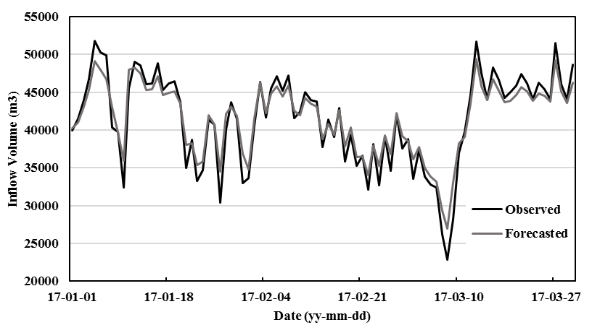
Figure 2. Comparison of predicted and observed inflow volume.
The ANN model developed in this study can be used to predict wastewater inflow volume for the improvement the performance of the wastewater treatment plant. Predicting the inflow volume with ANN, the efficiency of the predicting inflow volume could be improved by using the optimal number of input parameters instead of using various factors (Cho et al., 2014).
References
Breinholt, A., Thordarson, F. Ö., Møller, J. K., Grum, M., Mikkelsen, P. S., & Madsen, H. (2011). Grey-box modelling of flow in sewer systems with state-dependent diffusion. Environmetrics, 22(8), 946–961. https://doi.org/10.1002/env.1135
Capodaglio, A. G. (1994). Evaluation of Modelling Techniques for Wastewater Treatment Plant Automation. Water Science and Technology, 30(2), 149–156.
Cho, S., Lim, B., Jung, J., Kim, S., Chae, H., Park, J., … Park, J. K. (2014). Factors affecting algal blooms in a man-made lake and prediction using an artificial neural network. Measurement, 53, 224–233. https://doi.org/10.1016/j.measurement.2014.03.044
El-Din, A. G., & Smith, D. W. (2002). A neural network model to predict the wastewater inflow incorporating rainfall events. Water Research, 36(5), 1115–1126. https://doi.org/10.1016/S0043-1354(01)00287-1
Wei, X. (2013). Modeling and optimization of wastewater treatment process with a data-driven approach. Industrial and Systems Engineering Research Conference.
Wei, X., & Kusiak, A. (2015). Short-term prediction of influent flow in wastewater treatment plant. Stochastic Environmental Research and Risk Assessment, 29(1), 241–249. https://doi.org/10.1007/s00477-014-0889-0

